A√N Algorithm for Mutual Exclusion in Decentralized Systems
MAMORU MAEKAWA
ACM Transactions on Computer Systems, Vol. 3, No. 2, May 1985 pp.145-159
Abstract
An algorithm is prensented that uses only c√N messages to create mutual exclusion in a computer network where N the number of nodes and c a constant between 3 and 5.
- 1.Introduction
- 2.Request resolution
- For any combination of i and j, 1≤ i, j ≤ N, S_{i}∩S_{j}≠∅
- S_{i}, 1≤ i ≤ N, always contain i.
- The size of S_{i}, |S_{i}|, is K for any i. That is, |S₁|=|S₂|=|S₃|=...=|S_{N}|=K.
- Any j, 1≤ j ≤ N, is contained in the D S_{i}’s, 1 ≤ i ≤ N.
- 3.The choice of S_{i}’s
The maximum number of subsets that satisfy property (a) is given by
(D-1)K + 1
Since N is desired to be set to this maximum number so that K is minimized for a given N, we have
N = (D-1)K + 1
Furthermore, K = D must always hole, so
N = (K-1)K + 1
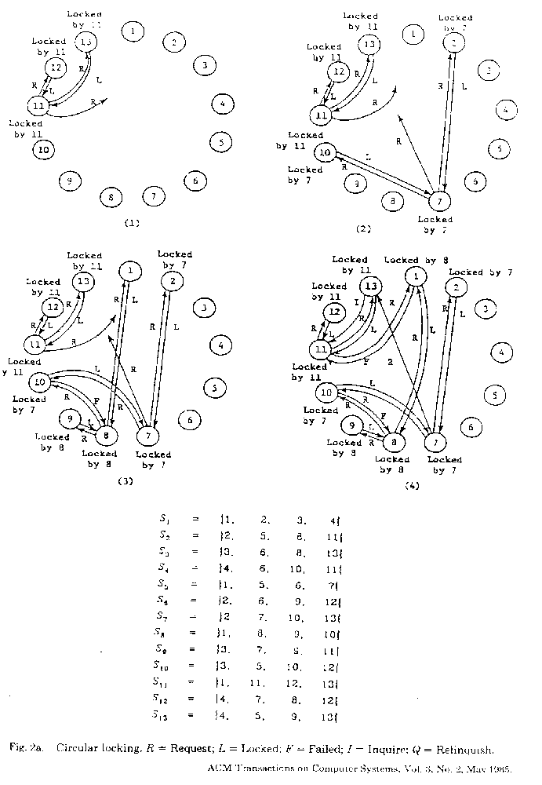
The creation of S_{i}’s:
S₁={1,2,3},S₂={2,4},S₃={3,5,4},S₄={1,4,5},S₅={2,5}
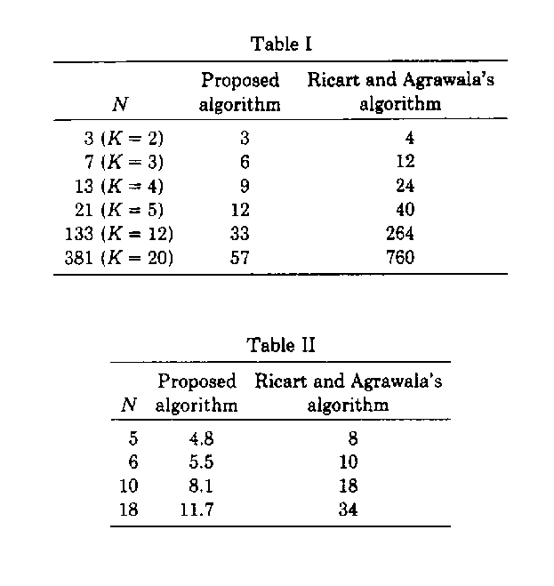
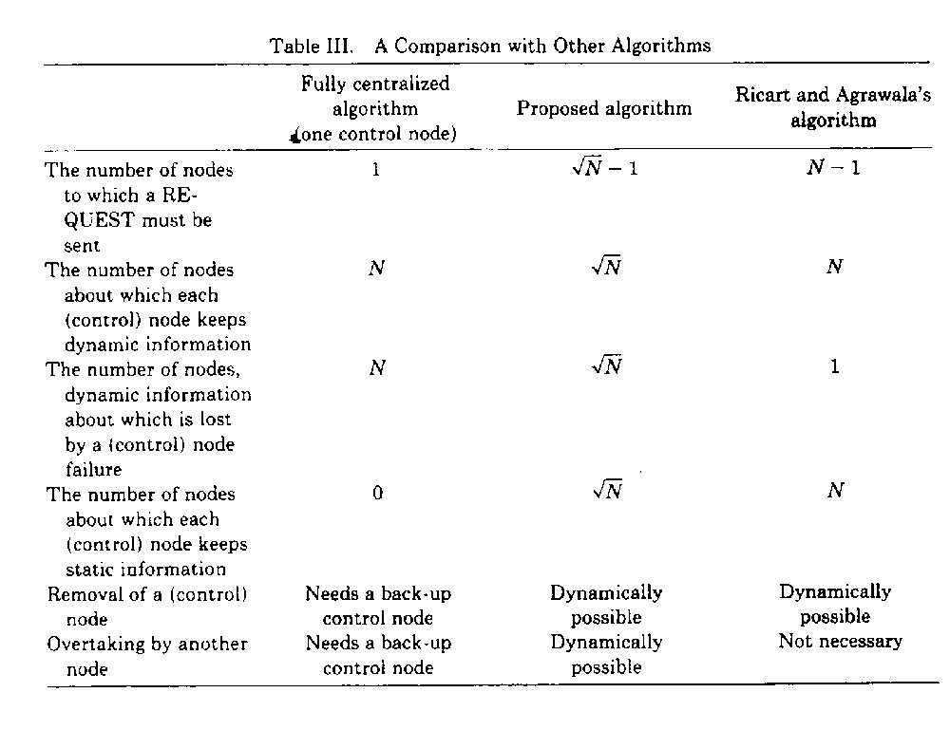
Created by : Kwo-Tsung Tseng
Date : Mar. 25, 1998

